Sri Lanka Institute of Information

Technology



Lab Submission

<Lab sheet 05>

**<IT24100816>**

**<Jayasena W.M.S.A>**

**Probability and Statistics | IT2120**

B.Sc. (Hons) in Information Technology

**1.**

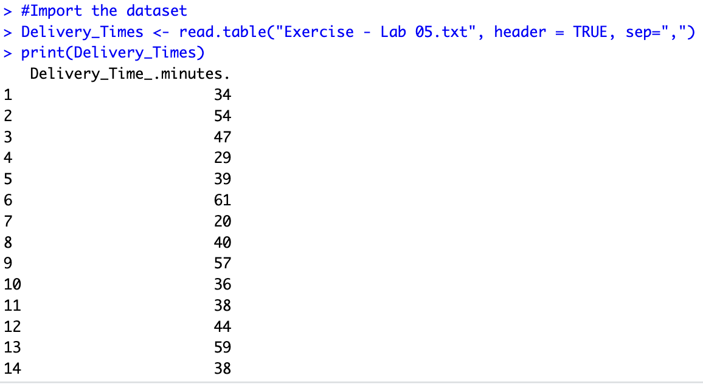

**2.**

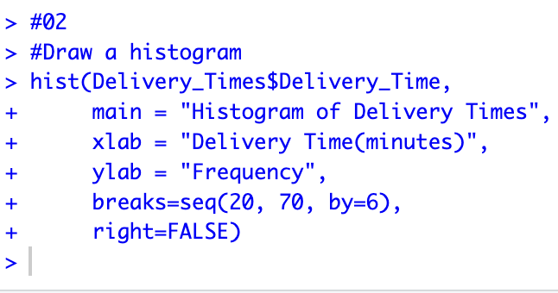

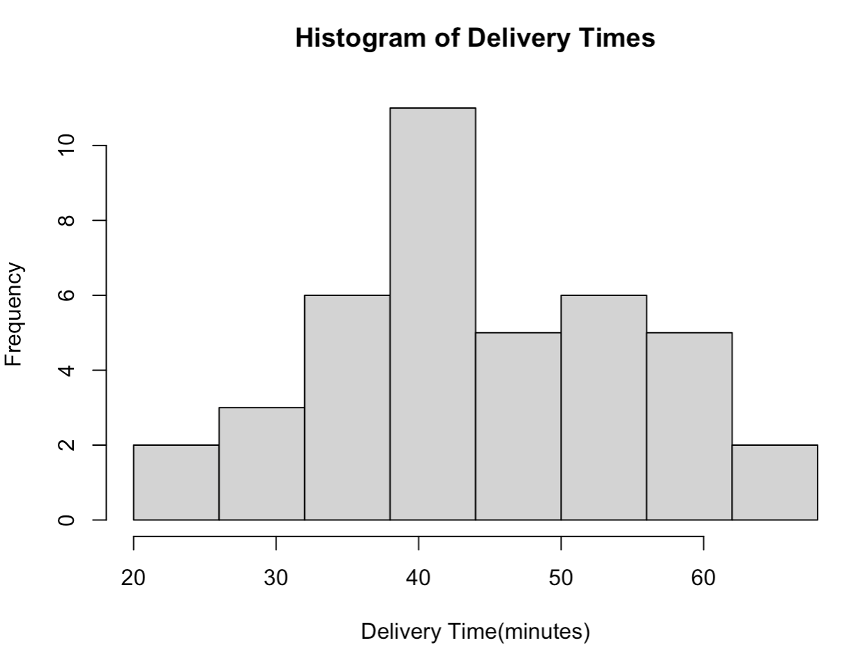

**4.**



